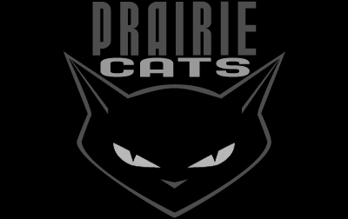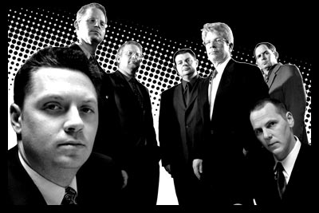

Press for the new album, “‘til the daytime fades”…

“...smooth and polished...not much new music is coming out like this anymore...a modern swing
feel with great songs and different styles...this CD will get a lot of airplay...”
- Swanktown Radio, Minneapolis / St. Paul

“...Prairie Cats mix big doses of easy humor with sharp-pressed musicianship...clever,
well-crafted original songs (that) encourage listeners to forget their troubles and dance awhile...”
- B.J. Huchtemann, The (Omaha) Reader

“...a reflection of a more mature group...has roots in swing and rockabilly, but
dabbles in jazz, blues and even hip-hop...”
- Christine Laue, Omaha World-Herald

"...14 cuts of big time original swing that's a blast...nice balance in tempo & mood.
These cats are hot & you'll have fun all night long!"

- Bo Lewis, Bo Lewis Big Band Dance Party

Press for Prairie Cats and their debut album, “The Big One”…

"A frisky ensemble (that plays) with a noticeable confidence...
tight and punchy...braiding traditional and modern swing, big band jazz,
rockabilly and pop, with a serious brass presence. Prairie Cats are just as
sharp live, and more unpredictable...”
- Jim Minge, Omaha World-Herald

"...smart swing that's never content to be just dance floor music...”
- Greg Bueno, Austin360.com

"...(The Big One) swings from start to finish...”
- Lincoln Journal Star

Very danceable and a pleasure to listen to...”
- Swing Des Moines

Booking/Contact: 402-556-2027 | Web: www.prairiecats.com

