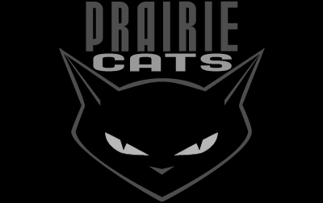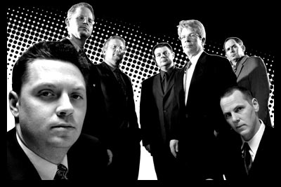

Prairie Cats hail from the very heart of the heartland – Omaha, Nebraska. Formed in late summer of 1998, the 8-piece band delivers an all-original "pop-swing" mix of jump-blues, big band, rockabilly, latin and bop, delivered in an all-out rock attack. But it all swings, Jack...make no mistake about it.
Prairie Cats have been rocking numerous venues and festivals, drawing rave reviews and pulling together a loyal fan base of the finest cats and kittens. They've opened for the likes of Royal Crown Revue, Indigo, Big Six, 8 1/2 Souvenirs, Love Dogs, Red Elvises and The Camaros, and headlined shows at major hotspots like L.A.'s famous Derby, the World Trade and World Financial Centers in NYC, and the prestigious South By Southwest music festival in Austin, TX. They remain one of the top draws in the Midwest, whether it's at one of their packed club dates or at outdoor shows like their record-breaking Jazz On The Green 2001 and 2003 performances in Omaha, attended by more than 6,000 fans. All while having more fun than you can shake a martini at!
The band's much-anticipated second CD, “'til the daytime fades,” was released independently in April of 2001 through the Cats' own Behave Records label, and is available at regional Homer’s and Borders locations and distributed worldwide by Hepcat Records based in Anaheim, Calif. The album features 14 diverse original tunes, recorded and mastered by esteemed engineer Jim Homan at Omaha’s Ware House Studios. The album is already garnering rave reviews, and truly captures the energy and versatility that have endeared the Cats to their fans and solidified the group as one of the region’s top bands on the scene.
The Cats' successful debut CD, “The Big One,” was released in the summer of '99. It was one of the summer’s top-selling CDs at Omaha's Homers record stores, and was recognized as one of the top albums of the year by Swanktown, a radio show in the Twin Cities.
The Cats’ music has been recognized and included in several “best of” and “top 10” lists, including ATOMIC magazine, Swanktown and SwingTop40.com. Their new CD has also been nominated for Album of the Year by SwingAwards.com.
So slip on your finest fines and head on downtown for the Cats' next gig! A good time is guaranteed, you swinger, you!

Booking/Contact: 402-556-2027

Web: www.prairiecats.com E-mail: cats@prairiecats.com

